1. What are the various elements of the Excel interface? Describe how they're used.

Ans : After opening the worksheet, we can observe the below interface where we can see options like quick access bar, ribbons, ribbon options and group, rows, column, formula bar, name box, sheet tab, status bar etc.

* + Workspace/ Worksheet: The area made by the intersection of rows and columns where records can be store is workspace. We can also call it as a collection of cells.
  + Ribbons/ Ribbon Controls/ Ribbons groups: On double clicking the ribbon option we can hide or unhide the option of ribbon controls and ribbon groups.
  + Name box: Name box is a place where we can see the cell reference of the cell or group of cells or it can also be used to switch between multiple tables in the worksheet.
  + Quick access bar: Quick access bar can be on top left of the excel interface can be set below the ribbon tab where we can see or pin some of the command on it.
  + Formula bar: Formula bar is use to input the data into the cells and using this bar we can also apply formulas to the cells.
  + Sheet tab, Status Bar & Zoom and view options: Below the worksheet we can see these following options which is use to see or manage the worksheet in the workbook, status of the worksheet & various aggregate functions which we had selected to show in status bar and zoom-in or zoom-out and page break option in these tabs respectively.

1. Write down the various applications of Excel in the industry.

Ans : For maintaining various records like Financial Analysis, Data Analysis, Project Management, Inventory management, Research and Data Collection, sales insights & profit calculations, HR & performance records, Strategic analysis, account management etc.

1. On the ribbon, make a new tab. Add some different groups, insert commands in the groups and name them according to their commands added. Copy and paste the screenshot of the steps you followed.

Ans : Steps are…

* Go to file ribbon
* Then click Option tab, excel option tab , where we can get option of customize ribbons tab.
* Then we have to use new tab or group option to select desired commands.
* The new tab is added as per our requirement with the command we select.

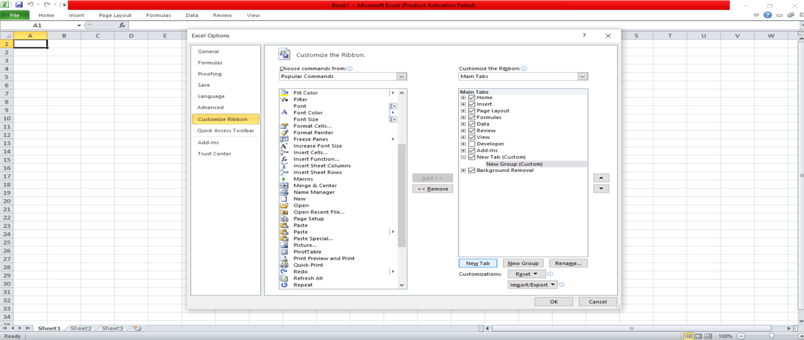

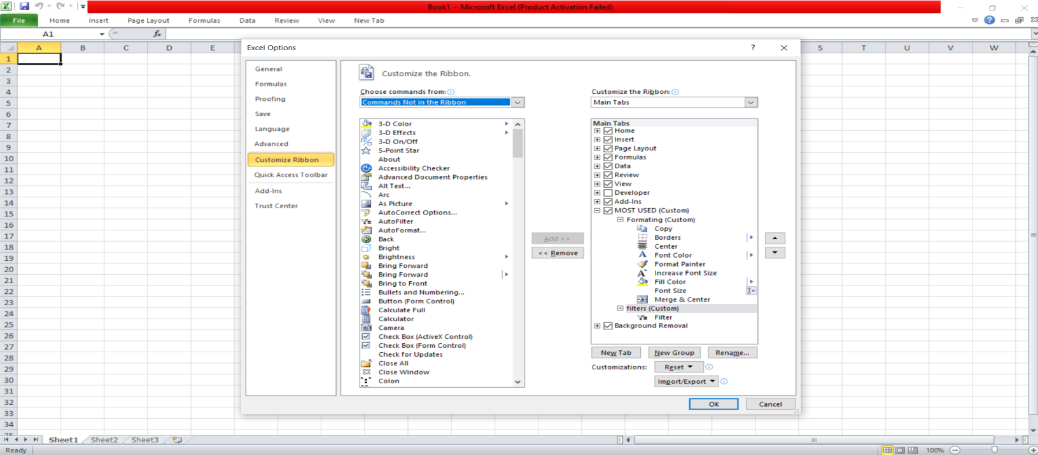

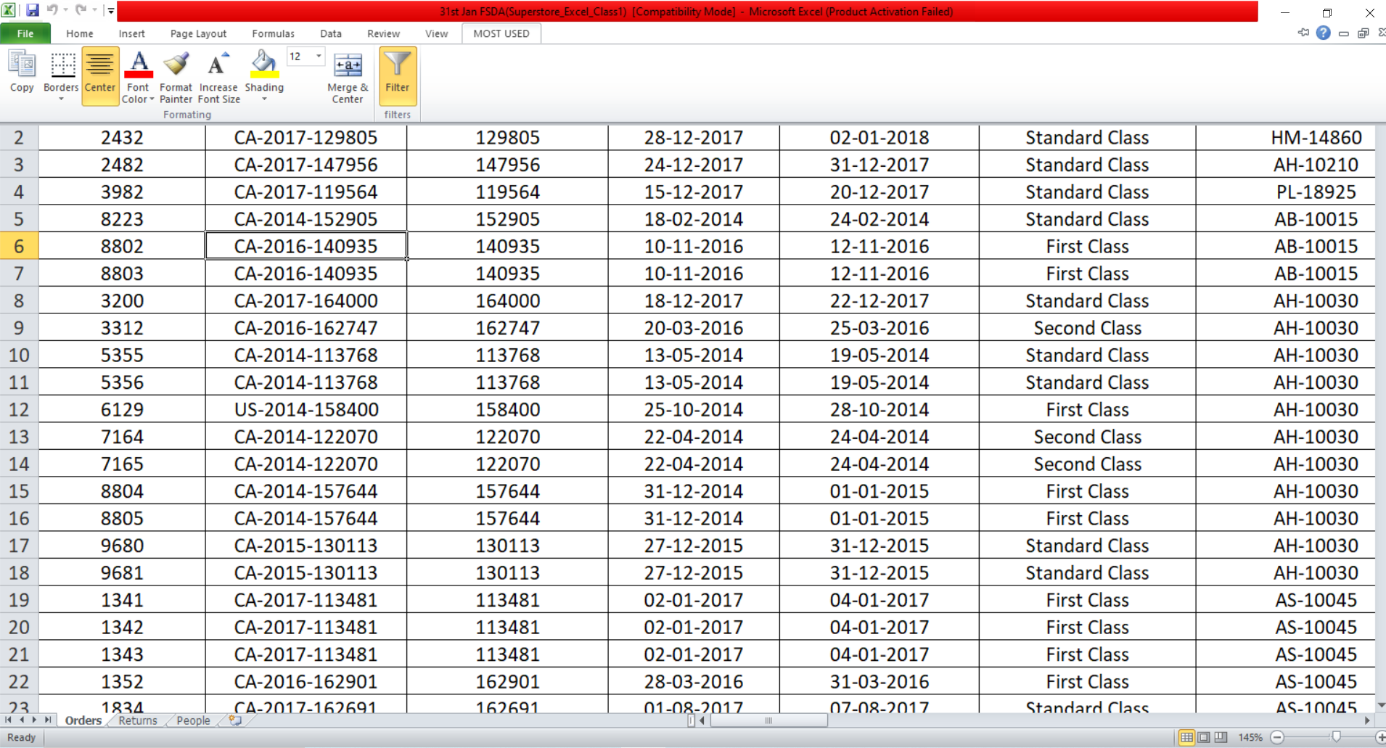

4. Make a list of different shortcut keys that are only connected to

formatting with their functions.

Ans : Here's a list of commonly used shortcut keys for formatting in Excel

|  |  |
| --- | --- |
| * Ctrl+x | Use to cut the selected items. |
| * Ctrl + c | Use to copy the selected items. |
| * Ctrl + v | Use to paste the selected copied or cut items. |
| * Ctrl + b | Use to bold text. |
| * Ctrl + u | Use to underline text. |
| * Ctrl + i | Use to make the text italic. |
| * Ctrl + 1 | Use to open format cell dialog box. |
| * Ctrl + 0 | Use to hide column. |
| * Ctrl + 9 | Use to hide row. |
| * Ctrl+Shift+ + | Use to insert the row/column/cell(s). |
| * Ctrl + - | Use to delete row/column/cell(s). |

* Ctrl+ B Apply bold formatting
* Ctrl+ I Apply italic formatting
* Ctrl+ U Apply underline formatting
* Ctrl+ 1 Open the Format Cells dialog box
* Ctrl+Shift+F Apply the Currency forma

5.What distinguishes Excel from other analytical tools?

Ans : Majority of firms are using excel as a primary tool as it provides various operation from maintaining records to build MIS report or dashboard.

* It is easy to learn and use.
  + It can be used to clean data, do the analysis using different data analysis options like “What-if”, goal-seeker, do the forecasting, Scenario manager etc.
  + It can be used to build models and we can do the statistical analysis also.
  + There are vast number charts available and various customization can be done.
* Overall, it’s an application which can do a lot of things like modelling, visualization, reports, dynamic charts, etc. with a very rich learning resource.

6.Create a table and add a custom header and footer to your table.

Ans : Steps are …

* + Go to “Page Layout” ribbon.
  + Under the “page setup” ribbon group, click on the extend option on the right-bottom part of the group.
  + “Page setup” window will pop up.
  + Go to Header/Footer tab and customize them and apply the change.